A
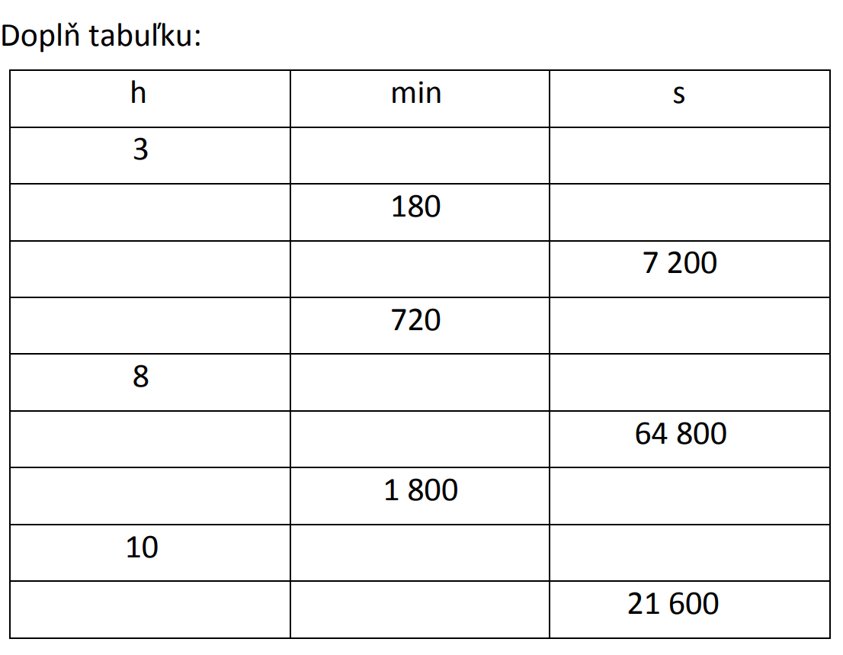
2 h = min

0,5 h = s

30 min = h

720 s = min

3 h 20 min = min

9 000 s = h

6 h 5 s = s

240 s = min

8 min 30 s = s

1 h 15min 6 s = s

B
3 h = min

0,2 h = s

45 min = h

900 s = min

5 h 40 min = min

18 000 s = h

4 h 12 s = s

300 s = min

6 min 20 s = s

2 h 10 min 5 s = s

